Independent's Day
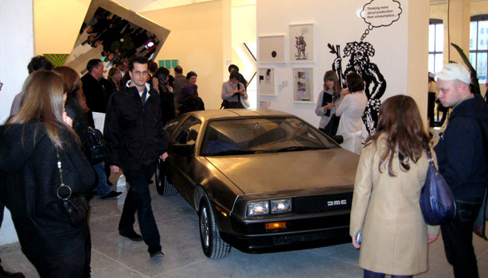
By Andrew M. Goldstein
A vintage Delorean was the centerpiece of Artists Space's stand at Independent.
By Andrew M. Goldstein, Sarah Douglas

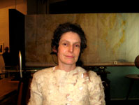
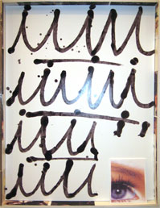
By Sarah Douglas
A mixed-media work by Nikolas Gambaroff that sold at Balice/Herting's booth for about $5,500

NEW YORK— At around 3 p.m. in the former Dia building — and now former X Initiative space — on West 22nd Street, New York dealer Stefania Bortolami could be found taking a break from feather-dusting her large Tom Burr sculptures to air kiss Miami collector Mera Rubell, who was visiting Bortolami Gallery's stand with her husband, Don. Such was the scene just before the opening of Independent, the much-buzzed hybrid non-art-fair art fair that gallerists Elizabeth Dee and Darren Flook organized as a collective-minded alternative to the other bazaars filling New York this Armory Week. Though billed as a grassroots venue with a greater emphasis on exhibiting art than selling it, the affair was decidedly high-toned — and avid. As a silver Rolls Royce idled outside, the Rubells joined a pool of other power collectors (Howard Rachofsky, for one) in previewing the wares on display in the stands, while organizers of other art fairs — including Frieze’s Amanda Sharp and Matthew Slotover, and Art Basel’s Marc Speigler and Annette Schonholzer — and the occasional artist (Maurizio Cattelan) took in the event's open-floor layout.
Spread throughout the building's four floors was a curated selection of 40 indie-spirited exhibitors, both dealers — from Turkey's Rodeo gallery to New York's Dispatch — and non-profits, like Artists Space and heady art publications October and Farimani. As with many of the events organized in the space by X Initiative (also founded by Dee), a refreshingly communal, engaged, and (almost) informal atmosphere pervaded the space. Independent Curators International's energetic Kate Fowle, who brought to the fair material from MIT List Visual Arts Center curator Joao Ribas's "FAX" show and other exhibitions the organization has mounted, had an espresso machine in her booth and was dispensing coffees with alacrity to whomever requested one. She was enthusiastic about the dialogues occurring between the exhibitions at different stands, which most participants had installed without the traditional drywall partitions seen at art fairs. “This space allows connections between things, and for things to breathe,” said Fowle.
When the doors to Independent officially opened, a host of art-world taste-makers and collectors streamed into the galleries. A popular destination was New York dealer Ed Winkleman's booth, which exhibited Eve Sussman’s stage-set reconstruction of Russian astronaut Yuri Gargarin’s office, complete with map, globe, desk and carpet. (Winkleman first showed the piece in his gallery last May.) Sometime after the public opening, a woman climbed into Sussman’s installation, and the artist was on hand to pounce. “No, no, no, you can’t do that,” she admonished. In an undertone she added, “You can do that if you buy it.” The piece is priced at $85,000.
While organizers Dee and Flook object to Independent being called a fair, “everyone knows we’re here to sell,” said Daniele Balice of Paris gallery Balice/Hertling. Indeed, he had already sold one piece at the opening — a mixed media work by Nikolas Gambaroff priced at about $5,500 — and had others on reserve. “People like to say that New York doesn’t need another fair,” the dealer said. “But this disproves that. It’s smaller, and more interesting than other fairs.” And though sales were being handled discreetly — there's a slightly transgressive aspect to dealers conducting business out of an exhibition context, which is what made the hybrid event exciting — they were certainly in effect at other booths during the opening.
London dealer Laura Bartlett, for instance, was able to part with two photographs by Cyprien Gaillard, priced at $5,000 apiece, and a large installation by Nina Beier for $11,500. “If it was in a convention center or something, if it was just another Armory Show, we wouldn’t have done it,” Bartlett said. “This is creative and ambitious, more of an exhibition approach than a sales-dominated approach.” Sutton Lane director Cora Muennich, who sold a large abstract Cheyney Thompson painting during the opening hours for $75,000, concurred. “This is much better than the Armory Show,” said the dealer, who did the marquee New York fair three years in a row before stopping with the 2008 edition. “The artists were really interested in showing here, and it’s nice to have daylight.” Behind her, the last rays of the day’s sunlight were streaming in through tall windows, a touch often absent at art fairs.
Los Angeles art dealer Tim Blum, who was playing hooky from his ADAA booth to tour the premises, was appreciative of the event. “It's really hard to create something that feels fresh, and it hasn't really been done since the hotel fairs of the 1990s," he said. “This feels spontaneous, serious, fresh, and clean. It doesn't feel uptight or anything. It feels like a community again." He said he had been particularly taken by work by Christian Frosi at the booth of Milan's Galleria Zero. “Seeing one thing you like at an art fair is rare, so that's pretty good,” he added. Over at the October booth, Yale art historian and critic David Joselit was trying on his vendor's hat, offering Benjamin Buchloh's monograph on Gerhard Richter and other books by the post-structuralist journal's authors. “I think anything that pluralizes the ways that galleries or art fairs show art when people come to town is a good thing,” he said. “Since this building was where Dia started — and, really, they created Chelsea — and then X Initiative, the space is almost a palimpsest for ways of looking at art." Independent, he noted, seemed to fit into the series of “instances in recent years where commerce and institutional critique have blended together.”
The positive buzz at Independent had Paris dealer Carlos Bellanger, who’d been invited to participate but did not, feeling a little disappointed that he hadn’t accepted. “It looks great,” he said. “The architecture, mixed with the high quality of the exhibitors. There’s nothing kitsch or cynical here.” Speaking of his own situation, he added equitably, “Regret is an issue but not something one wants to think about.”
If the hybrid fair was collaborative on a grand scale, it was also so in individual displays. Design guru Murray Moss, of the Soho store Moss, teamed up with art advisor Thea Westreich and her husband and business partner, Ethan Wagner, to mount a display mixing design objects from Moss’s collection and artworks from the couple's holdings. (Along with Matthew Higgs, director of New York alternative space White Columns and another participant at the fair, Westreich was an artistic advisor for Independent.) This made for a series of evocative juxtapositions, such as a piece by Maarten Baas, who takes others' designs and burns them (in this case a charred Ettore Sottsass shelving unit that Moss commissioned from Baas in December), standing next to a photograph of a woman in a wheelchair holding a mask in front of her face, from Diane Arbus's final series. “Independent is the real art world,” Westreich said. “The art world is much more collaborative than people think."
There were some downsides to using the building for a fair. The lighting, which had been muted and low during X Initiative's run, was turned up high to a nearly hospital-level blare, and the largely bare walls of the space ricocheted with chatter. But by and large Independent was considered a rousing success. "Fairs aren’t usually fun," said art advisor Stefano Basilico. “This is. It works." He added, “My fear is that it won’t work a second time around.” Why? “There will be a hundred more galleries who want to do it, and the whole '%*@#-you' attitude could get chipped away.”
Perhaps because of the feeling that something new was afoot, dealers appeared to be in good spirits. Berlin's Johann Konig, who was sharing space with Andrew Kreps, was showing a large rotating mirrored sculpture from 2007 by Jeppe Hein — "the most ambitious artwork” in the fair, he boasted. Told that a woman had just been checking her make-up in the $87,000 vanity, Konig smiled. “As long as we can be helpful to the community, we’re happy!”

